QUIETER HOME PROGRAM

Information for Realtors

About the Program:

The Quieter Home Program (QHP) is the San Diego County Regional Airport Authority’s Residential Sound Insulation Program. It helps reduce aircraft noise inside homes near San Diego International Airport.

Program Goal:

Reduce interior noise by at least 5 decibels (dB) through sound insulation treatments.

What we Provide:

- Retrofit exterior doors
- Retrofit windows
- Ventilation or air conditioning systems

Eligibility:

- Residentially zoned property within the 65 dB CNEL contour
- Habitable areas with average interior noise ≥ 45 dB (windows/doors closed)

Eligible communities:

- Loma Portal / Ocean Beach
- Bankers Hill / Middletown
- Golden Hill / South Park

Check eligibility on our Program Boundary Map:
www.san.org/Airport-Noise/Quieter-Home-Program

Historic Evaluation:

Each home is evaluated for historical significance and classified as Historic or Non-Historic for
Program purposes only.
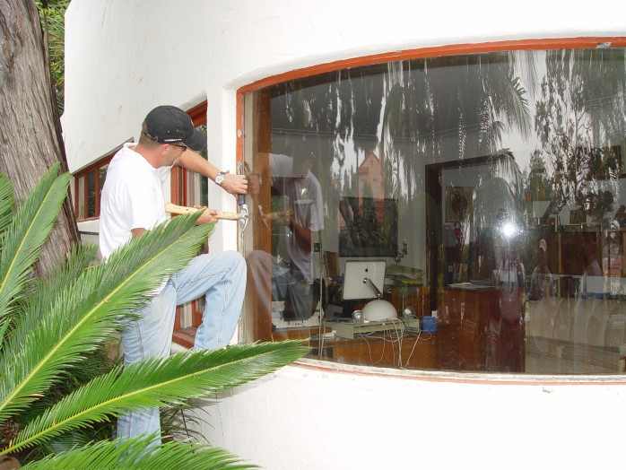

Key Facts:

- Over 6,000 homes treated
- Priority: loudest areas, then longest ownership
- If sold, new owner inherits waiting list position (must apply)
- Wait times can be several years

Once in a construction group:
- 8 mandatory meetings
- 1–2 years for planning
15–30 business days for construction

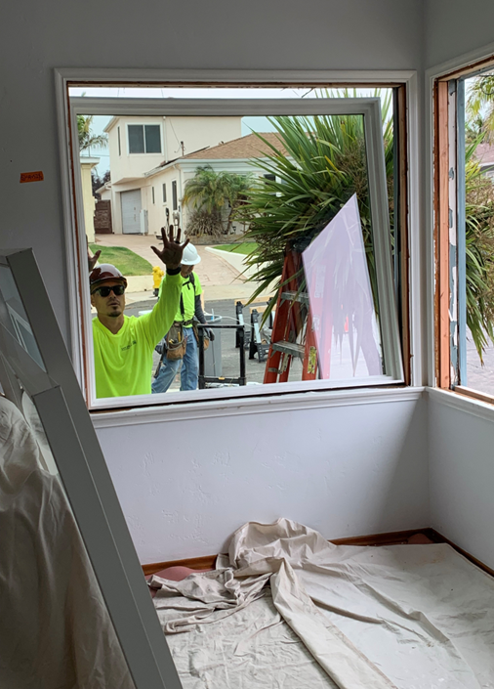

Learn more and Apply: www.san.org/Airport- Noise/Quieter-Home-Program


